Table of Contents

- INTRODUCTON

- GAME SET-UP

- COUNTER SET-UP

- VICTORY CONDITIONS

- COMBAT BOARDS

-5.1 Using the Combat board

- PLAYING PIECES

- GAME MAP
-7.1 Factor numbers on hexes
-7.2 Factor number in combat
-7.3 Map icons
-7.4 Partial Hex’s

- THE SEQUENCE OF PLAY

9.0 RE-SUPPLY
-9.1 Re-supply Saxons
-9.2 Re-supply Vikings/Britons
-9.3 Viking&Briton Areas of influence for RSP

- MOVEMENT
-10.1 Somerset Levels Movement
-10.2 Viking Sea Movement
-10.3 Coastal Fortified Hex’s
-10.4 Britons Sea Movement

- COMBAT
-11.1 General Rules
-11.2 Combat Sequence
-11.3 Combat (sneak attack) and hiding in the Somerset Levels

12.0 RETREAT
-12.1 retreating movement point

13.0 EXEANCEASTER

- BRITISH REVOLT

15.0 DIRECT ASSULT ON FORTIFIED HEX’S (FH) (CASTLES, TOWNS AND RELIGIOUS AREAS

16.0. SEIGE OF FORTIFIED HEXS (FH)
-16.1 Breaking a Siege

17.0. SAXON LOSS OF SHIRE FYRDS

18.0. EARL ODDA OF DEFNASCIR

19.0 UBBE LOTHBROK

20.0 WALES AND WHIT

21.0 DESIGN NOTES

22.0 GAME COMPONENTS
____________________________________

Free Upgrade offer!

Dear Customer,
If you contact me at:mark@redkinggames.com and supply me with your receipt number from Wargame Downloads, I will place you in my “Alfredians” email group and you will receive free any updates, changes or rule variations made to this PNP game.
Regards
Mark H.Sheppard

Credits

Research & Development: Mark H.Sheppard

Design: Mark H. Sheppard

Graphics(excluding map): Alen Jablanovic

Map Icons: Are the alternate icon set from Hexographer by Artist Keith Curtis

Rule Book version : 1.0

©Mark H.Sheppard 2014

- INTRODUCTION
Welcome to the second game in the Alfred the Great (ATG) campaign series.

In the first game: ATG the Great Heathen Army 871AD, Alfred had led the West Saxons to victory of a sorts, spectacular but not comprehensive.

Ivar the Boneless the Great high King of the Vikings is dead, killed in Ireland in 873AD and his Lothbrok kin, Halfdan and Ubbe had traveled north to fight the Picts and the Britons of Strathclyde, And then to Ireland, to reclaim the land lost by Ivar.

This left Guthrum and his fellow Kings Anwend and Oscetel to mount another attack on Wessex.

What kind of plan had Guthrum hatched? We know that he moved 1,500 men quickly and with stealth and seized the fortress of Wareham. There to be joined by a huge fleet of 3,500 Vikings.

Fortified Wareham Situated on the Southern coast of Wessex had proximity to the West Country Fyrds of Devon and Dorset that Guthrum would need to bring to battle, a safe harbor for his warriors that had traveled by ship but also he was within striking distance of Winchester, the capital of the West Saxons and a town that Guthrum would know that Alfred would defend at all costs.

There has been strong speculation that Guthrum had discussed with Halfdan and Ubbe Lothbrok a joint plan of attack, one possible scenario could have Halfdan landing in Exeter (that had a strong British quarter) where the groundwork had possibly been laid with the Britons of Cornwalum to stage an uprising against their Saxon lords.

The Britons had bad memories of the slaughter after their last uprising and defeat by King Egbert in 836AD (Alfred’s grandfather) and would have needed some strong persuasion but a three pronged attacked from Guthrum in Wareham, The Britons and Halfdans army from Exeter and Ubbe landing a force in the North of Devon or Somerset would have stretched Alfred’s army to a breaking point.

The last King of Cornwalum was Doniert and it is mentioned that he died sometime around 875AD by drowning, presumably while out hunting but it is claimed in Irish annals that he was drowned for his collusion with the Vikings, did Alfred seek revenge for a traitor on his border? Or did a leading West Saxon Earl hunt him down and exact vengeance?

Unfortunately for Doniert and Guthrum, Halfdan was killed in Ireland and Ubbe was probably involved in seeking retribution (the Lothbroks did have a history of revenge!)

In Wareham, Guthrum after making a deal with Alfred, killed all his hostages and fled to Exeter with his house troops while the rest of his army readied to sail to Exeter, possibly this was a last roll of the dice to get the Britons to stick to their plan but Unfortunately for Guthrum his fleet was sunk in a storm off Swanage and his plan (and fleet) was literally sunk.

In this game Halfdan is dead but Ubbe is ready to attack, the Britons of Cornwalum can be brought into the game, but only the wily Guthrum has the ability to convince Doniert to join the invasion, but first he has to go Exeter…

The Viking strength was in their professional and aggressive soldiery skills, their weakness was often in re-supply of fighting men and the fact the West Saxons were fighting for their home.

Kings are of great importance in the game, when they are leading the warriors in combat your moral and thereby fighting ability is increased, without them weakened.

The Saxons have a number of strengths, fighting on home soil made easier re-supply and greater access to troops from the Shires, the flipside was that the Fyrd as the local militia was called had their immediate loyalty to their Earl and Shire, and the defeat of their home Shire would mean a lessening of their commitment to the Kings Army.

The game commences with the Vikings after hearing about the death of Halfdan in Ireland have arranged a truce with Alfred at Wareham, hostages have been swapped and Ale drunk and the Saxons are returning to their farms and villages, the smell of treachery is in the air……………

2.0 2.0 GAME SET-UP

- Place all counters on board as per Counter set-up

- Place game turn counter on game turn chart on “Start”#1

- Place RSP markers on RSP chart
(See #9.0)
- Both players are allocated their respective Combat Boards.

- Viking Player always moves first.

3.0 COUNTER SET-UP

Vikings-
Wareham Hex-
Kings: Guthrum, Anwend and Oscetel
7 Jarls
90 Warriors

Wales (any hex) Hex-
King: Ubbe
3 Jarls
22 Warriors

Britons-
Exanceaster-
1 Uchelwyr
2 Warriors

Saxons-
Wintanceaster Hex-
King Alfred
1 Earls
10 Warriors

Exanceaster, Cridianton and Ascanmyaster
1 Warrior

Wilton, Hamtun, Baoum,
(Each) Hexes-
1 Earl
40 Warriors

Dornwarceaster, Tweoxneam and Brydian
(Each) Hexes-
1 Earl
20 Warriors

Sceapt, Cippanhanum&Welegaford
10 Warriors

Contesberia
Odda
30 Warriors

4.0VICTORY CONDITIONS

Vikings-
Major Victory
(1) Is achieved if Alfred and Odda are killed and Wintanceaster has been captured.

Minor Victory
(1)At the completion of the 15th turn Viking&Briton combined victory points are greater than 40+

Saxons-
Major Victory
.
(1)All Viking Kings in Wessex have been killed before end of turn 15

If Ubbe Lothbrok is still in Wales and the 3 Viking Kings are killed he has decided to return to Ireland (Game over)

Doniert (if active) and the Britons on the death of all the Viking Kings in Wessex decide to flee the Saxon Wrath (Game over)

Minor Victory
- At the completion of the 15th turn Saxon victory points are greater than 70+

Stalemate-If one side does not reach the required points by turn 15 the game is a draw.

5.0 COMBAT BOARDS (CB)
Combat boards are used when there is a large battle being conducted; both sides remove their counters from map and place on their respective CB.
You can place a Combat Marker on the hex to mark where the battle is happening.

For smaller battles you can leave the counters on the map and conduct combat as per combat rules.

5.1 Using the Combat board (CB)
-Place your Warrior counters on the warrior section, Earls in the Earl Section and Kings on King Section.

-Roll the Die and check the Earls/Jarls/Uchelwyr& Warriors Hit or Miss Table (on your CB) to see if you Hit or Miss your opponent, (you will have a better chance if a King is leading the attack).

-If a “Hit” by your Warriors&Earls/Jarls/ Uchelwyr count how many Warriors you have in the combat and check the Warriors killed Table (on your CB) to see how many enemy you have killed. Do the same with the Earls/Jarls /Uchelwyr killed table.

-Kings: roll a separate die and check the charts under there Kings Name for result.

-Add together the killed results from Warriors&Earls (or Jarls/ Uchelwyr) and any Kings present, plus if defending from a Fortified hex add that as well for a total number of enemy causalities

6.0 PLAYING PIECES

Dice
You will need (minimum) 1 die to play the game, or if you have 2 dice (one for Warriors& Earls/Jarls/ Uchelwyr and one for Kings) of a different color you can roll both dice at once.

Playing Pieces
Each counter on the lower left has a “Number” of counter values -3 stands for 3 counters, these can be changed (anytime)during play to reduce size of counter stacks, and a Movement number on the lower right that shows how many hex’s this counter can move.

- 1 Warrior counter represents approx. 50 men; they have a movement allowance of 2 hexes per turn.

- 1 Earl/Jarl/ Uchelwyr Counter represents 1 Earl/Jarl/Uchelwyr and his household troops, they are mounted and can move 5 hex’s per turn.

- King Alfred/Viking Kings Counter represents Alfred/Viking Kings and his/their household troops, they are mounted and can move 5 hex’s per turn.

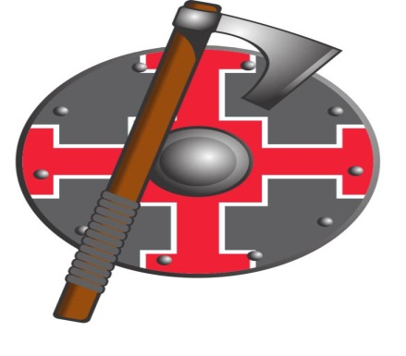
Saxon
3-Number of Counters 2-Movement

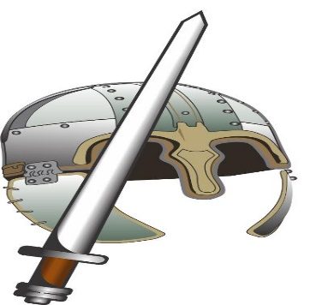

Earl
3-Number of Counters 5-Movement

King
Alfred
Movement 5

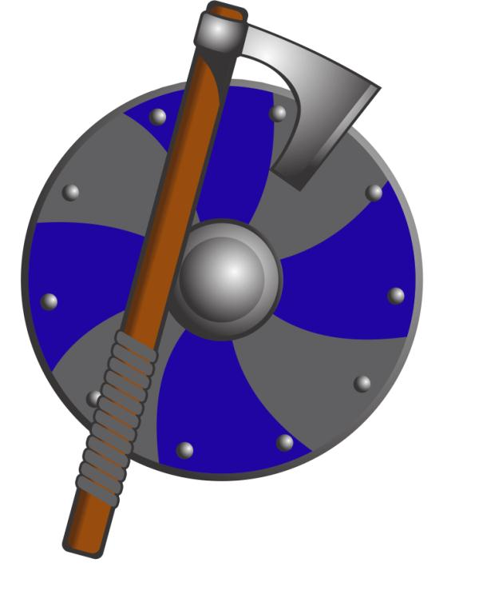
Viking
3-Number of Counters 2-Movement

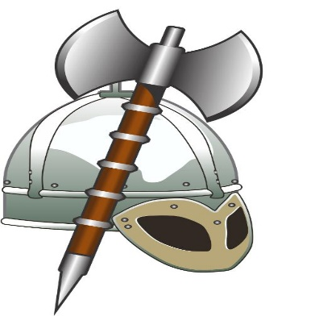
Jarl
3-Number of Counters 2-Movement

King
Guthrum
Movement -5

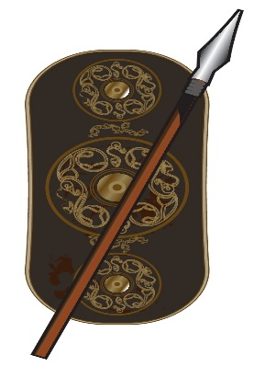
Briton
3-Number of Counters 2-Movement

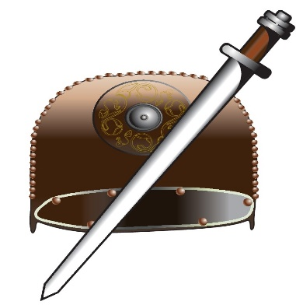
Uchelwyr
3-Number of Counters 2-Movement

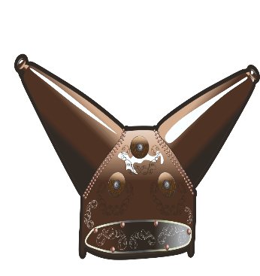
King
Doniert
Movement -5

7.0 GAME MAP
7.1 Factor numbers on hexes [+]

Each Castle, Town, Religious Area and Village has a factor number, they are used for-
-Re-supply points (RSP)
-Victory points (VP)
-Combat (except Villages)

7.2 factor number in combat

As long as you’re Warriors&Earls/Jarls/ Uchelwyr or any King present rolls a “hit ‘you add on the factor number of the Fortified Hex to how many enemy figures you have killed

7.3 Map icons

 | Castle | +4 on Combat Result, Victory points and re-supply.  1 movement Pt.  (They are a Fortified Hex :FH)
 | 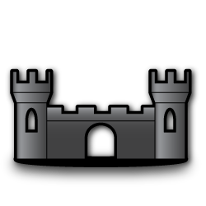  Town | +3 on Combat Result, Victory points and re-supply.  1 movement Pt.  (They are a FH)
 | 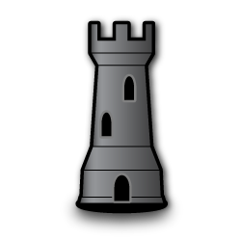  Religious Area | +2 on Combat Result, Victory points and re-supply. 1 movement Pt.  (They are a FH)
 | 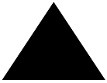  Village | +1 on Victory points and re-supply has no Combat value.
 | 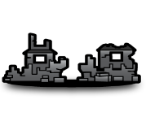Iron Age Forts | Iron Age Forts have no Factor number but have to be breached or placed under siege as per all FH. 1 movement Pt.
 | 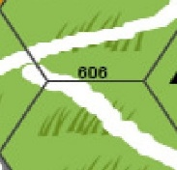  Ancient Roads | No combat value, Takes 1 Movement Pt. to move into and through any Hex that the Road passes through.
Hills |  | No Combat value, takes 2 movement pts. To move through.
Forest |  | No Combat value, takes 2 movement pts. to move through.
River Temes |  | No Combat or Movement value except for Viking sea movement.(R#10.2)
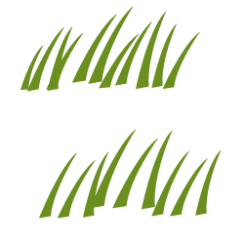Grass |  | No Combat value, takes 1 movement pts. To move through.
Levels(Marsh) |  | See (R#10.1) Somerset Levels Movement
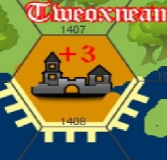  Beach |  | Beach hexes are only entered by land to create a siege they take 1MP per hex. Or in a direct sea assault by Vikings.(#11.4)

7.4 Partial Hex’s

Along the bottom Coast line of Wessex from hex #209 to #1708 there are partial land hexes, these are all to be treated as Full Hex’s-as long as a hex has green land in hex it is a normal hex. The same applies to hex’s along the Safern Sea from hex # 102 to #1100

8.0 THE SEQUENCE OF PLAY
[1] Re-supply (If Applicable)
[2]Movement
[3]Combat
[4]Adjust RSP Chart

Once both players have completed this the turn is over

9.0 RE-SUPPLY
Re-Supply takes place when designated on the game turn chart.
Place the RSP counters for the Saxon, Britons and Vikings on the Re-supply chart (found on the game turn chart), these can be moved along as Re-supply points are gained or lost during game play.

At the commencement of the game
-The Saxons start on 83 RSP.
-The Vikings start on 3RSP.
-The Britons have none at start.

Each turn you have re-supply you use up to the amount of RSP points you have on the chart and purchase counters.

Counters cannot be re-supplied into a Fortified Hex that is under siege.

9.1 Re-supply Saxons-
Add the Re-Supply points (RSP) of all Villages, Religious areas, Towns and Castles that are not held by Vikings. Or Britons

From this total it costs-

Earl,Jarl and Uchelwyr | 5 Pts
Warriors (All) | 1 Pts
They can be placed in Wintanceaster or Town not held by Vikings/Britons
Total of Re-supply points on Map

Villages | 23
Religious Areas | 14
Towns | 45
Wintanceaster | 4
Total points (available) | 86

9.2 Re-supply Viking&Briton

Vikings and Britons must have a minimum of 1 Warrior stationed in any Village, Religious area, Town and Castle to count the re-supply point, there must be no Saxon counter present in these hexes.

Any Hex with a RSP returns to Saxon control once the Vikings/Britons have moved out, the Saxons do not have to have a counter present.

Vikings are re-supplied into any coastal FH hex or FH hex that the Temes runs through that does not have Saxons present. If there are no FH hex’s available re-supply is cancelled for this turn.
(See Rule#10.3)

Britons are re-supplied onto any hex to the west of Exanceaster (Hex#102 thru to 109)

9.3 Viking&Briton Areas of influence for RSP
In hexes that have both Viking and Briton present at Re- supply time everything west and south of Tone Tun Hex#505, 506,507 and 508 are always controlled by the Britons, everything east of this line is Viking.

I.e. Vikings control Tone-Tun early in game, Briton counters move on to reinforce the Tone-Tun Hex, Tone-Tun is then counted as a Briton RSP not Viking.

10.0 MOVEMENT.
Players can move their counters into or thru an opposing enemy’s hex (except Fortified hexes)up to their Movement Point (MP) allowance, you cannot enter a hex if you do not have enough MP left to enter-i.e. if you have 1 left you cannot enter a hill or forest hex.
If sharing a hex, Combat is optional.
I.e. there is no Zone of Control (Z.O.C) exerted in general play.
The exception is Fortified Hexes (FH) -Religious areas, Towns, Iron Age Forts and Castles that are occupied by enemy figures.
These are manned and have to be moved around.

When moving onto or along a road it only costs 1 movement point per hex.

10.1 Somerset Levels Movement
-Saxons move thru the levels at 1 MP per hex

-Vikings/Britons-takes 2 MP to move into a full Levels hex but they must roll a 6 on die to move out of the hex.(including retreating) If a 6 is rolled they then move as normal, if unsuccessful they are stuck in the hex, only 1 roll per turn per hex.

-this does not include partial levels hexs-404,604 and 704 they are all 1 MP only.

10.2 Viking Sea Movement
-There must be a Jarl or Viking King in counter stack then Vikings can move by longboat from a Viking controlled coastal FH to another controlled coastal Viking FH or any coastal FH that is not garrisoned by Saxons, this costs no MP, if they have any MP left after sailing to new FH they can then move there balance of MP.
I.e. a large stock of Vikings sail from Werham to Abbendum, they have used no MP they then launch a land attack throughout the Villages and Towns of Berrocscire.

10.3 Coastal Fortified Hex’s
Welengaford, Abbendum, Hamptun, Tweoxneam, Werham, Exanceaster, Brycgstow, Contesberia and Cynuit.

10.4 Britons Sea Movement
-Britons can ride on the Viking long boats but there must be a Viking King or Jarl present in combined Briton/Viking stack……………………………………………………………………………………………………………………………………………………………………………………………………………………………………………………………………………………………………………………………………………………………………………………………………………………………………………………………………………………………………………………………………………………………………………………………………………………………………………………………………………………………………

